# **Deployment ASP.Net Core application**

## Task 1: Deploy your ASP.Net Core application to your local IIS server.

1- enable iis server in windows

2- create web site on iis

3- publish to iis folder (*C:\websites\WeatherApi*)

4- browse the api [localhost:8083/api](http://localhost:8083/api)

## Task 2: Deploy your ASP.Net Core application to Azure App Service.

1- Create new azure service app

2- publish to azure app service

3- browse the api [appservice03-01-2024.azurewebsites.net/api](https://appservice03-01-2024.azurewebsites.net/api)

## Task 3: Deploy your ASP.Net Core application with Docker:

1- install **Docker Desktop** for windows

2- add the docker file from my project

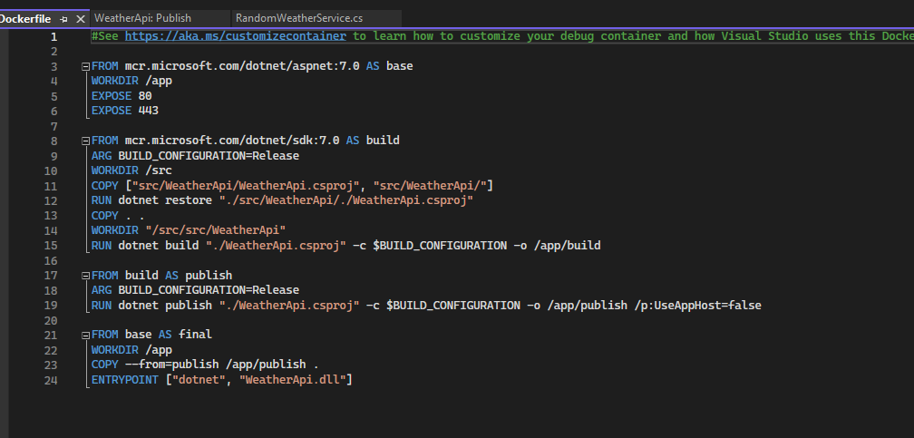

3- publish to Docker Container Registry ( Docker Hub )

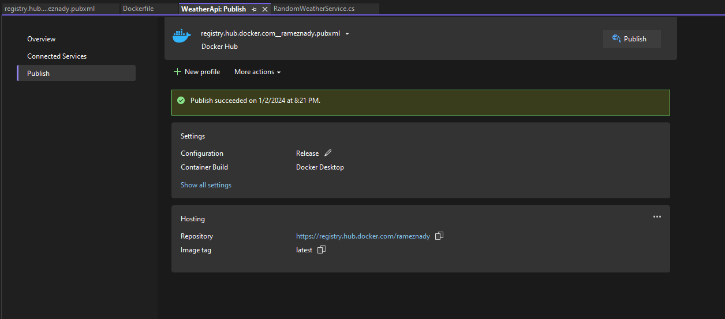

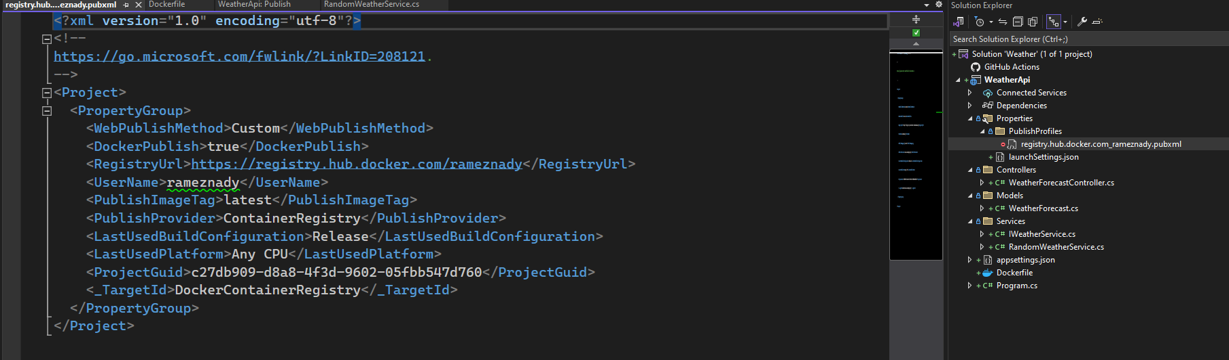

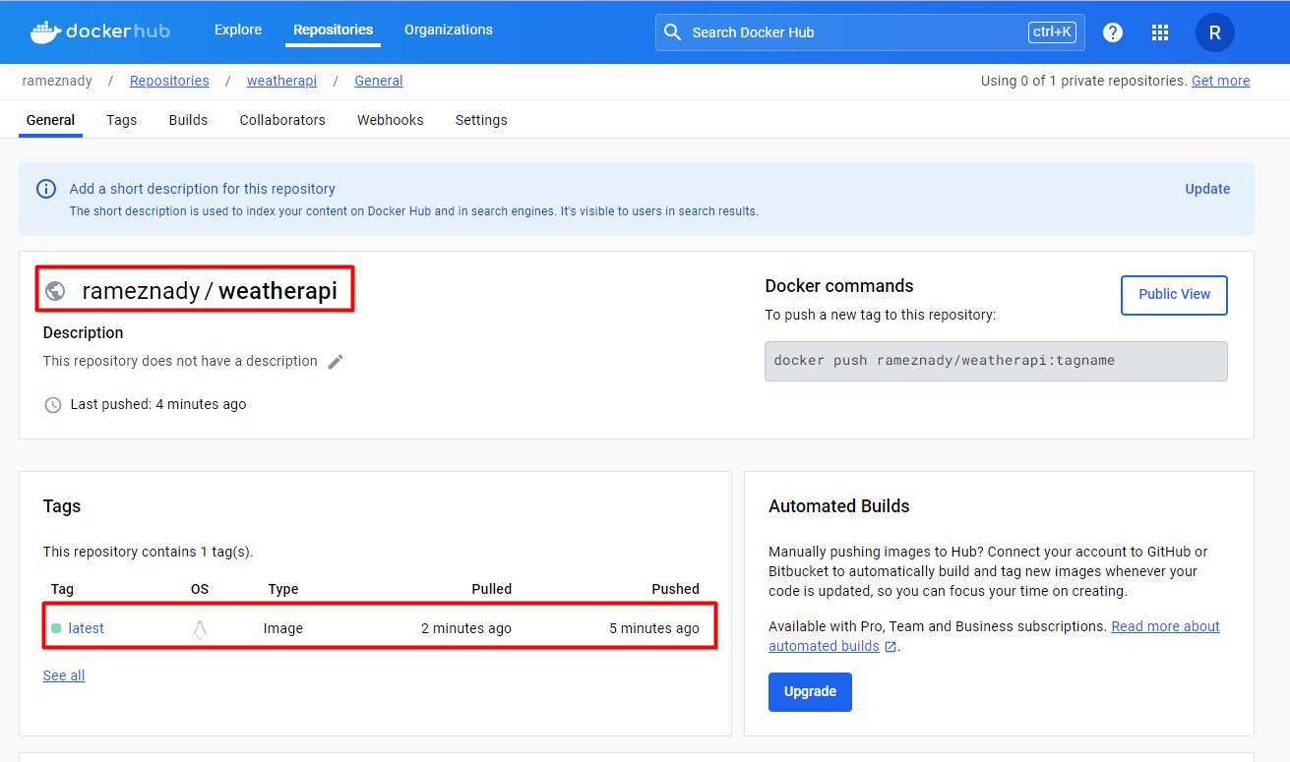

4- Create azure app service (AppService02-01-2024)

5- browse the api [appservice02-01-2024.azurewebsites.net/api](https://appservice02-01-2024.azurewebsites.net/api)

6- increase the object list returned (inside the code) and publish again to the docker hub repo.

6- browse again the api [appservice02-01-2024.azurewebsites.net/api](https://appservice02-01-2024.azurewebsites.net/api)

